BACK-TO-SCHOOL, THE MAKING OFF

We will see the preparation of this presentation following the 6-steps recipe of Cole Nussbaumer:
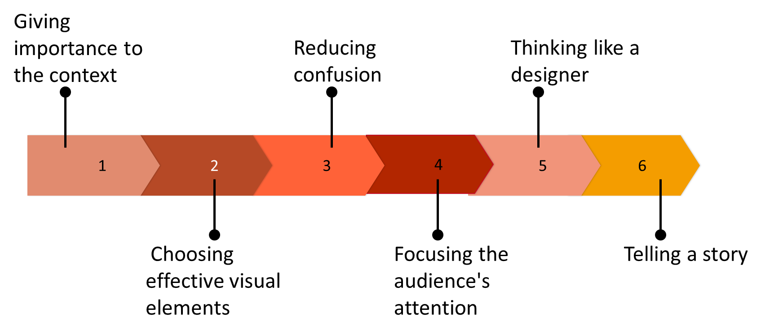

Step 1. Giving importance to the context
In this step we will set up the elements of the story through storyboarding
We retrieve the context and the big idea: audience, benefits and risks and recommendations.

1a. We brainstorm the elements of the story

1b. Organize
PROBLEM
ACTION / ANALYSIS
OUTCOME | OPPORTUNITY: | RECOMMENDATION:) | DISCUSSION / APPROVAL

Step 2. Choosing effective visual elements

Step 3. Reducing confusion

Step 4. Focusing the audience’s attention

Step 5. Thinking like a designer
[postponed until graphic designer part]

Step 6. Telling a story: The narrative arc




